Firmware Source Code of
C-Media CM66xx-A USB 2.0 Controller

Programming Guide

C-MEDIA Electronics Inc.

Revision History

Revision | Date | Description
1.0 | 2012/7/11 | First version
1.1 | 2013/1/17 | For library v1.4, add support of fast-mode I2C.  Keep XBANKING.LIB alone.
1.2 | 2013/4/9 | Modify macros definition in chapter 6.
3.0 | 2014/1/20 | Open the source code of HID, MIDI, timer, uart.  Supports CM6210.

Contents
1. Introduction 4
1.1 Features 4
1.2 Architecture 4
2. Files and Build 5
2.1 Source Tree 5
2.2 Build and Update 6
2.3 Naming Rules 7
3. Memory Space 8
3.1 Program Memory 8
3.2 Data Memory 8
4. The Common APIs 9
4.1 APIs of Peripheral Control 9
4.1.1 Basic Data Type 9
4.1.2 Common Public Variable 9
4.1.3 Common Macros 9
4.1.4 Common Functions 10
4.1.5 Peripheral Control 10
4.1.6 Timer 11
4.1.7 UART Interface 11
4.2 APIs of USB Control 12
4.2.1 Structures for USB control 12
4.2.2 Public Variables for USB control 15
4.2.3 Functions for USB control 15
4.2.4 Call back Functions for USB control 16
4.2.5 USB MIDI Class 16
4.2.6 USB HID Class 17
4.2.6.1 HID Report Descriptor 18
4.2.6.2 HID Input Report 19
4.2.6.3 HID Output Report 20
4.3 Design an USB Audio Device 20
5. Audio Module 21
5.1 Start and Stop the Streams 22
5.2 Audio APIs 23
6. Custom Module 23

Introduction
CM66xx-A is a family of M8051-based chips for USB audio device. It complies with USB 2.0 specification for both full speed and high speed. Besides control endpoint 0, CM66xx-A provides three isochronous-in endpoints for ADC, three isochronous-out endpoints for DAC, two interrupt-in endpoints, one bulk-in endpoint, and one bulk-out endpoint. The most flexible feature is that there is an internal 8051 MCU in CM66xx-A. Users can program RM5001 to do anything. Not only USB audio device but also USB mass storage device or USB keyboard can be achieved by RM5001.

The CM66xx-A firmware framework provides an easy-to-use firmware platform to simplify the firmware development process of designing an USB 2.0 audio device with CM66xx-A family – CM6620A, CM6631A, …. . This document acts as a programmer’s guideline for developers who need to design firmware based on CM66xx-A firmware framework.

There are several sample applications of USB audio devices in the framework package. These sample applications can be run on C-Media’s EVB. Users can modify these applications to develop different kinds of USB devices.

Features
The features of CM66xx-A firmware framework are listed below.
- Supports USB 2.0 high-speed and full-speed operation.
- Supports USB HID class 1.1.
- Supports USB midi class 1.0.
- Supports USB audio class 1.0 and 2.0.
- Users can design user-defined USB device easily.
- Users can easily control peripherals of CM66xx-A including GPIO, UART, …
- The clock of MCU 8051 is 48MHz.

Architecture
CM66xx-A firmware framework includes folders –“Common”, “6631A_6632A” and “6631A_6632A_UsbDAC”. The folders “6631A_6632A_UsbDAC” and “6631A_6632A” are two example applications. Users can modify the codes by themselves to meet their requirements. The other folder “Common” contains common drivers and files for all applications.
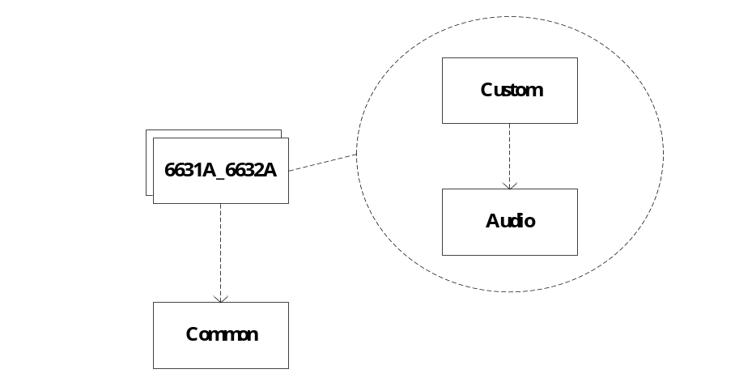
- Main folders in CM66xx-A firmware framework

In folder “6631A_6632A”, there are two subdirectories – “Audio” and “Custom”. The files in directory “Audio” implement USB audio class 1.0, audio class 2.0 and the control sequence of audio codec. If users want to support different audio format or need to drive different codec, they have to modify the files in this directory. The other directory “Custom” contains all USB descriptors and the control of device-specific behavior.

Files and Build
This chapter introduces the files in CM66xx-A firmware framework and how to build the applications.

Source Tree
The files tree is shown below.

66xxA_OpenSource\
Doc\ - Documents of CM66xx-A firmware framework
6631A_6632A\ - Sample code of CM6631A and CM6632A
Audio\ - Source codes of USB audio class and codec’s driver
Custom\ - Source codes of user-defined behavior
make.bat, build.bat - Batch files for building the whole project
6631A_6632A_UsbDAC\ - USB DAC by CM6631A and CM6632A(DSD)
Audio\ - Source codes of USB audio class and codec’s driver
Custom\ - Source codes of user-defined behavior
make.bat, build.bat - Batch files for building the whole project
Common\
Boot\ - CM66xx-A’s boot code
Driver \ - Driver of peripherals and timer
Usb\ - USB driver
Hid \ - USB HID class
Midi\ - USB MIDI class

The source files, header files, library file of CM66xx-A firmware framework are listed in the following table.
Directory | Files | Description
Common\Boot\ | CM66xxBoot.hex | Boot code for CM66xx-A
Common\Boot\ | AddInfo.exe | Utility for inserting boot code
Common\Driver | cm66xx.h, common.h, peripheral.c, peripheral.h,  timer.h, timer.c,  uart.h, uart.c | Definition of CM66xx-A’s registers  Peripheral control  timer control  UART control
Common\Usb | usb.c, usb.h  request.c | USB control  USB requests’ handler
Common\Hid | hid.h, hid.c, | Source code of USB HID class
Common\Midi | midi.h, midi.c, | Source code of USB MIDI class
6631A_6632A\ | make.bat, build.bat | The batch files for building application
6631A_6632A\Audio\ | audio.h, audio.c, audio10.c, audio20.c | The source codes of USB audio class 1.0/2.0
6631A_6632A\Custom\ | config.h, device.c  startup.a51, dscr.a51  Audio10FullSpeed.conf  Audio10HighSpeed.conf  Audio20FullSpeed.conf  Audio20HighSpeed.conf | The sample codes of an USB audio device

Build and Update
CM66xx-A firmware framework and the sample applications are built by the toolchain of Keil uVision. They have been built successfully by complier C51 V8.05a, assembler A51 V8.00b, and linker LX51 V4.09.

In the directory of sample application, there is a batch file “build.bat” for building the sample application. Users can build the firmware easily by executing “build xxxx” (xxxx means the version number) under the directory “Audio Device” in Windows’ console. Users can modify these batch files according to users’ requirement.

After building firmware, users get different hex files which can be downloaded into flash by different ways. Files “6631A-xxxx-ALL.hex” and “6631A -xxxx-APP.hex” are for updating via USB cable by C-Media’s PC update tool. The other file “6631A-xxxx-ROM.hex”, users can program it into flash by any popular flash programmer.

Please note the byte order of a word or double word in source codes. Because the toolchain of Keil uVision uses big-endian byte order, it is different from USB’s byte order little-endian. Users need to care about this issue.

Naming Rules
There are some naming rules in the source codes. The prefix “g_” means the variable or function is global, it can be access everywhere. The prefix “s_” means the variable or function is static, it can be access only in its private scope. However, the same as global variable, static variable occupies memory in the beginning and lives forever.

Memory Space

Program Memory
The program memory and data memory are separated into different spaces. The program memory is located in flash, and the total size of program memory is 64 Kbyte. The layout of program memory is shown below. The sector architecture of the flash CM66xx-A uses is based on uniform sector size of 4 Kbyte. The first sector (0~0x0FFF) is for boot code. The second sector (0x1000~0x1FFF) is reserved for some configurable parameters, such as VID, PID, product string, and so on. The firmware of users’ application is located in section 0x2000~0xFFFF.
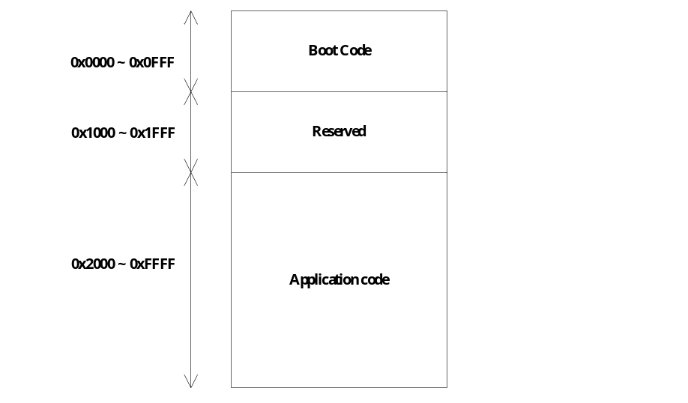
- Program memory space

Data Memory
The total size of data memory is 256 byte. The section 0~0x7F is called “DATA” section and is accessible using direct addressing. The other section 0x80~0xFF is called “IDATA” section, and is accessible using indirect addressing. The memory 0x60~0x7F is reserved for stack.
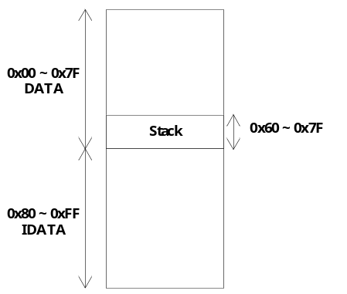
- Data memory space

The Common APIs

APIs of Peripheral Control
The header files cm66xx.h, common.h, peripheral.h, timer.h, and uart.h define the structures and functions for CM66xx-A’s peripheral control. All the definition of CM66xx-A’s registers are put in cm66xx.h.

Basic Data Type
The basic data types are defined in “common.h”.
Data Type | Description
BYTE  WORD  DWORD  BOOL | unsigned char, one-byte data  unsigned short, two-byte data  unsigned long, four-byte data  bit, one-bit only

Common Public Variable
These public variables are listed below.
Variable | Attribute | Description
BYTE g_Index  BYTE g_TempByte1  BYTE g_TempByte2  WORD g_TempWord1  WORD g_TempWord2  void* g_Pointer | R/W | These variables are used for buffering data temporarily for general purpose. When using them, users should take care of avoiding overwritten by other functions.

Common Macros
The common macros are defined in “common.h”.
Macro | Description
MSB(word)  LSB(word) | Return the high byte of “word”.  Return the low byte of “word”.
min(a,b)  max(a,b) | Return the minimum among “a” and “b”.  Return the maximum among “a” and “b”.
TRUE  FALSE  NULL | 1  0  0

Common Functions
Function | Description
void PERI_WriteByte(WORD addr, BYTE value)  void PERI_WriteWord(WORD addr, WORD value)  BYTE PERI_ReadByte(WORD addr)  WORD PERI_ReadWord(WORD addr) | These functions are used to access registers of CM66xx-A via internal peripheral bus.
BYTE GetLibVersion() | Return the version of the library. Currently the number is 0x10 which means version 1.0.

Peripheral Control
For peripheral control, Cm66xx-A library provides functions and global variables. They are defined in “peripheral.h”. The functions for peripheral control are listed below.

Function | Description
void PeripheralProcess() | This function is the process of GPIO handling. This function should be called in main loop.
BYTE FlashRead(WORD addr) | Return the data in flash memory at address “addr”.
void SendHdaCommand(BYTE node, WORD verb, WORD payload) | Control HDA controller to send a verb to HDA codec.
void SpiWriteByte(BYTE chip_select, BYTE map, BYTE value)  BYTE SpiReadByte(BYTE chip_select, BYTE map) | Access codec or some salve chip via SPI interface. They only support reading/writing one byte at one time.
void I2cMasterWrite(BYTE addr, BYTE map, BYTE* buf, BYTE len)  void I2cMasterRead(BYTE addr, BYTE map, BYTE* buf, BYTE len) | Access codec or some salve chip via I2C interface. The maximum of data length reading/writing at one time is 8-byte.  By default, the I2C will operate with standard mode 100k bps. If users want to operate with fast mode 400k bps, uses can call with the macro “I2C_FAST_MODE” as the following example:  I2cMasterWrite(addr, map, &tmp, I2C_FAST_MODE | 1);

The main loop will call functions “HandleGpi” and “HandleGpio” if the IO status changes.
Callback Function | Description
void HandleGpi () | GPI event handler. It is called in main loop.
void HandleGpio () | GPIO event handler. It is called in main loop.

There are also some public variables for peripheral’s event notification.
Macro | Description
BOOL g_I2cSlaveRequest | Notification from CM66xx-A’s I2C-slave module. Users should check registers USB-AB to get what happens.
BOOL g_SpdifInRequest | Notification from CM66xx-A’s SPDIF-in module. Users should check registers USB-71 to get what happens.
BOOL g_HdaRequest | Notification from CM66xx-A’s HDA controller when receiving unsolicited response from codec.

Timer
Cm66xx-A library provides a global variable for timer usage. The variable is listed below. The variable “g_Tick10ms” which is defined in “timer.h” will increase every 10ms automatically. Users can derive their own timers from the 10ms time tick.

Variable | Attribute | Description
BYTE g_Tick10ms | RW | Time tick of 10ms interval.

UART Interface
Cm66xx-A library provides functions for UART communication. The functions for UART are defined in “uart.h” and are listed below. There are TxQueue and RxQueue in Cm66xx-A library. When users want to read or write data, they just get the data from RxQueue or put the data into TxQueue with the APIs Cm66xx-A library provides.
Function | Description
void UartInit() | Reset TxQueue and RxQueue.
BOOL TxQueueIsFull()  BOOL RxQueueIsEmpty() | Check if TxQueue is full.  Check if RxQueue is empty.
void PutIntoTxQueue(BYTE value)  BYTE GetFromRxQueue() | Put the data “value” into TxQueue.  Get one byte from RxQueue.

The baudrate of UART is configured in function PowerOnReset() in device.c. The default baudrate is 31250 bps for MIDI interface. When USB MIDI is enabled, the UART interface will be dedicated to MIDI usage. So if users want to setup UART for application other than USB MIDI, they have to configure baudrate in PowerOnReset() and disable USB MIDI.

APIs of USB Control
As the block diagram shown below, Cm66xx-A library provides not only USB basic function but also MIDI class and HID class. In “Cm66xx-A\Include\”, there are header files usb.h, hid.h, and midi.h. The file “usb.h” defines the basic structures and the functions for USB control. And the files “hid.h” and “midi.h” define the USB interfaces of HID class and MIDI class, users can directly include them in their own USB device.
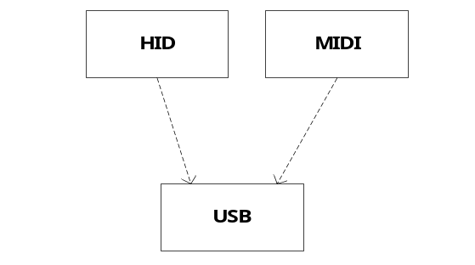
- USB functions in Cm66xx-A library

Structures for USB control
The structures described in this section are defined in “usb.h”. With these structures, uses can define many types of USB device.

- USB_REQUEST
typedef struct
{
BYTE type;
BYTE request;
BYTE value_L;
BYTE value_H;
BYTE index_L;
BYTE index_H;
BYTE length_L;
BYTE length_H;
} USB_REQUEST;

USB_REQUEST defines the structure of an USB request from host. It complies with USB specification.

- USB_ENDPOINT
typedef struct
{
BYTE number;
void* pInterface;
BOOL (*HanldeClassCmnd)(void*);
BOOL (*HanldeClassDataOut)(void*);
} USB_ENDPOINT;
USB_ENDPOINT defines an USB endpoint. Each member is described below.

Members | Description
number | Endpoint number of the USB endpoint
pInterface | Pointer to the USB_INTERFACE instance the endpoint belongs to.
HanldeClassCmnd | Pointer to the handling function for class request of the endpoint. If the endpoint doesn’t support any class request, fill it with NULL.
HanldeClassDataOut | Pointer to the handling function for class request’s data-out stage of the endpoint. If the endpoint doesn’t support any class request, fill it with NULL.

- USB_INTERFACE
typedef struct
{
BYTE maxAltSettingNumber;
BYTE* pAltSetting;
BYTE endpointNumbers;
USB_ENDPOINT* pEndpoints;
BOOL (*SetInterface)(void*);
BOOL (*HandleGetDesc)(void*);
BOOL (*HanldeClassCmnd)(void*);
BOOL (*HanldeClassDataOut)(void*);
} USB_INTERFACE;

USB_INTERFACE defines an USB interface. Each member is described below.

Members | Description
maxAltSettingNumber | The maximum alternate setting number of the interface.
pAltSetting | Pointer to the data memory which stores current alternate setting.
endpointNumbers | Number of endpoints in the interface.
pEndpoints | The array of instances of USB_ENDPOINT in the interface.
SetInterface | Pointer to the callback function for “Set Interface” request of the interface. If there is no callback function, fill it with NULL.
HandleGetDesc | Pointer to the callback function for “Get Descriptor” request of the interface. If there is no callback function, fill it with NULL.
HanldeClassCmnd | Pointer to the handling function for class request of the interface. If the endpoint doesn’t support any class request, fill it with NULL.
HanldeClassDataOut | Pointer to the handling function for class request’s data-out stage of the interface. If the endpoint doesn’t support any class request, fill it with NULL.

- USB_DEVICE
typedef struct {
BYTE* pDeviceDscr;
BYTE* pDeviceQualDscr;
BYTE* pConfigDscr;
BYTE* pOtherConfigDscr;
BYTE* pStringDscr;
BYTE interfaceNumbers;
USB_INTERFACE** pInterfaces;
void (*Configured)();
void (*Deconfigured)();
BOOL (*HanldeVendorCmnd)();
BOOL (*HanldeVendorDataOut)();
} USB_DEVICE;

USB_DEVICE defines an USB device. Each member is described below.
Members | Description
pDeviceDscr | Pointer to device descriptor of the device.
pDeviceQualDscr | Pointer to device qualifier descriptor of the device.
pConfigDscr | Pointer to configuration descriptor of the device.
pOtherConfigDscr | Pointer to other-speed configuration descriptor of the device.
pStringDscr | Pointer to array of string configuration descriptors of the device.
interfaceNumbers | Number of interfaces in the USB device.
pInterfaces | The array of pointers to instance of USB_ INTERFACE in the USB device.
Configured | The pointer to the callback function for “Set Configuration 1” request of the USB device. If there is no callback function, fill it with NULL.
Deconfigured | The pointer to the callback function for “Set Configuration 0” request of the USB device. If there is no callback function, fill it with NULL.
HanldeVendorCmnd | Pointer to the handling function for vendor request of the interface. If the endpoint doesn’t support any vendor request, fill it with NULL.
HanldeVendorDataOut | Pointer to the handling function for vendor request’s data-out stage of the interface. If the endpoint doesn’t support any vendor request, fill it with NULL.

Public Variables for USB control
Cm66xx-A library provides global variables for USB control. Users can access them directly. These public variables are defined in “usb.h” and listed below.

Variable | Attribute | Description
USB_REQUEST g_UsbRequest | RO | The 8-byte data of USB request from host.
WORD g_UsbCtrlLength | RO | The data length of data stage in control transfer.
BYTE g_UsbCtrlData[16] | R/W | Data buffer for handling USB request from host. Don’t use it except for handling USB request.
BOOL g_UsbIsActive | RO | TRUE: USB is active.  FALSE: USB is suspended or detached.
BOOL g_UsbIsHighSpeed | RO | TRUE: USB is operated in high-speed.  FALSE: USB is operated in full-speed.
BYTE g_UsbConfiguration | RO | Current configuration number.

Functions for USB control
For USB control, Cm66xx-A library provides functions which are defined in “usb.h”. These functions for USB control are listed below.

Function | Description
void UsbInit() | This function performs initialization of the USB engine.
void UsbProcess() | This function is the USB state machine process. It should be executed in main loop.
void RegisterUsbDevice(USB_DEVICE* device) | Uses call this function to register the USB device users create.
void SetUsbCtrlData(BYTE* buf, WORD len) | Pass the pointer “buf” which is the data will be handled in data stage and its length “len” to the USB engine.
void SendInt4Data(BYTE* buf, BYTE len)  void SendInt15Data(BYTE* buf, BYTE len) | Send the data “buf” with length “len” to host via interrupt-in endpoint 4 or endpoint 5.

Users should call UsbInit() in function PowerOnReset() in “device.c”. Then users need to create the USB_DEVICE structure and register it by RegisterUsbDevice(). The function “RegisterUsbDevice” should be called in callback function HandleUsbReset() in “device.c”. The input parameter “device” is the pointer to an USB_DEVICE structure. You can register different USB_DEVICE at any time depend on your requirement.

Call back Functions for USB control
Some functions need to be implemented in users’ application. Cm66xx-A library will call them when corresponding events happen. These callback functions are listed below.

Callback Function | Description
void HandleUsbReset() | USB reset event handler.
void HandleUsbResume() | USB resume event handler.
void HandleUsbSuspend() | USB suspend event handler.
void HandleInt4Complete() | This function is called when the data transfer of interrupt endpoint 4 is finished.
void HandleInt15Complete() | This function is called when the data transfer of interrupt endpoint 15 is finished.

In UsbProcess(), it will call HandleUsbReset(), HandleUsbResume(), HandleUsbSuspend(), HandleInt4Complete() and HandleInt15Complete() when the corresponding events happen. Users have to provide these callback functions. They may be implemented in device.c

USB MIDI Class
Cm66xx-A library provides implementation of USB MIDI class. Users can include it into their own USB device. USB MIDI class is constructed of a control interface and a stream interface. They are defined in “midi.h”.

Variable | Attribute | Description
USB_INTERFACE g_InterfaceMidiCtrl | RO | USB_INTERFACE instance of control interface of USB midi class. It can be used directly to construct a USB_DEVICE structure.
USB_INTERFACE g_InterfaceMidiStream | RO | USB_INTERFACE instance of stream interface of USB midi class. It can be used directly to construct a USB_DEVICE structure.

The functions for USB MIDI class are listed below.

Function | Description
void MidiInit() | This function performs initialization of the USB MIDI class engine. This function should be called in callback function HandleUsbReset()
void MidiProcess () | This function is the state machine of USB MIDI class. It transfers data between USB and UART. This function should be executed in main loop.

USB HID Class
Cm66xx-A library provides implementation of USB HID class. Users can include it into their own USB device. The public variables for USB HID class are listed below.

Variable | Attribute | Description
USB_INTERFACE g_InterfaceHid | RO | USB_INTERFACE instance of USB HID class. It can be used directly to construct a USB_DEVICE structure.
HID_INPUT_REPORT g_InputReport[16] | R/W | The buffer to keep HID input report. Fills in this buffer and calls SendInputReport() to send an input report to host.
BYTE g_OutputReport[16] | RO | The buffer to store HID output report.
BYTE code HidDscr  BYTE code HidReportDscr  BYTE code HidReportDscrLen |  | The client should provide the HID descriptors. In sample applications, they are defined in dscr.a51.

The definition of structure of HID_INPUT_REPORT is described below. Besides reporting the button event, Cm66xx-A library also embeds registers’ content into the input report. In this way, users can monitor CM66xx-A’s status on PC with HID tool.

typedef struct
{
BYTE button;
BYTE reserved1;
BYTE reserved2;
BYTE source;
BYTE offset_high;
BYTE offset_low;
BYTE length;
BYTE registers[9];
} HID_INPUT_REPORT;

Members | Description
button | The events of button, such as volume-up, volume-down.
source | The event source of this input report.
offset_high  offset_low | The high byte and low byte of “offset” which is the start address of “registers[9]”.
length | The length of registers’ data reported in “registers[9]”.
registers[9] | The registers’ content beginning from “offset”

The functions for USB HID class are listed below.

Function | Description
void HidInit() | This function performs initialization of the USB HID class engine. This function should be called in callback function HandleUsbReset()
void SendInputReport() | Sending the data in “g_InputReport” to host.

HID Report Descriptor
The HID report descriptor is declared in “dscr.a51”. It is also listed below.

05H, 0CH ; Usage Page (Consumer)
09H, 01H ; Usage (Consumer Control)
0A1H, 01H ; Collection (Application)
15H, 00H ; Logical Minimum (0)
25H, 01H ; Logical Maximum (1)
09H, 0E9H ; Usage (Volume Increment)
09H, 0EAH ; Usage (Volume Decrement)
75H, 01H ; Report Size (1)
95H, 02H ; Report Count (2)
81H, 42H ; Input (Data, Variable, Absolute, Null State)
09H, 0E2H ; Usage (Mute)
09H, 00H ; Usage (Unassigned)
81H, 06H ; Input (Data, Array, Relative)
09H, 00H ; Usage (Unassigned)
95H, 04H ; Report Count (4)
81H, 02H ; Input (Data, Variable, Absolute)
26H, 0FFH, 00H ; Logical Maximum (255)
09H, 00H ; Usage (Unassigned)
75H, 08H ; Report Size (8)
95H, 0FH ; Report Count (15)
81H, 02H ; Input (Data, Variable, Absolute)
09H, 00H ; Usage (Unassigned)
95H, 10H ; Report Count (16)
91H, 02H ; Output (Data, Variable, Absolute)
0C0H ; End Collection

HID Input Report
The 16-bytes input report is defined as the following table. Host will be notified by an input report via interrupt pipe. Host can also get input report with class request “Get Report” via control pipe.

Offset | Description | Size
Byte 0 | Button events.  Bit 0: Volume up  Bit 1: Volume down  Bit 2: Playback mute  Bit3~Bit7: Reserved | 1
Byte 1~Byte 2 | Reserved | 2
Byte 3 | Interrupt source.  Bit 0: GPIO  Bit 1: GPI | 1
Byte 4 | Register offset high byte | 1
Byte 5 | Register offset low byte | 1
Byte 6 | Register length | 1
Byte 7~Byte15 | Register content | 9

Host can get registers of CM66xx-A by HID input report’s byte 4 ~ byte 15. Start address and length of registers that host reads can be set by sending output report.

HID Output Report
The 16-byte output report is designed for writing registers to CM66xx. It is also used for setting start address and length of registers sent to host in input report.

 | Description | Size
Byte 0~Byte 3 | Reserved | 4
Byte 4(MSB) ~ Byte 5(LSB) | - 0x00FF: Set offset of reading in input report  - The register start address of writing | 2
Byte 6 | - If Byte4 ~ Byte5 is 0x00FF, this byte is the length of register reading in input report.  - If Byte4 ~ Byte5 is not 0x00FF, this byte is the length of data will be written to registers. | 1
Byte 7~Byte15 | - If Byte4 ~ Byte5 is 0x00FF, Byte 7(MSB) and Byte 8(LSB) are the start address of reading in input report.  - If Byte4 ~ Byte5 is not 0x00FF, Byte 7~Byte 15 are data will be written to registers. | 9

Design an USB Audio Device
With Cm66xx-A library, it is easy to build up a new USB audio device. Firmware engineers have to perform only three main tasks:

- Building up all USB descriptors for full-speed and high-speed. The descriptor files “Audio10FullSpeed.conf”, “Audio20FullSpeed.conf”, “Audio10HighSpeed.conf”, “Audio20HighSpeed.conf” and “dscr.a51” in folder “Custom” can be a good reference.
- Creating an instance (or instances) of USB_DEVICE structure corresponding to the USB descriptors. "device.c” in folder “Custom” is an example which shows how USB_DEVICE is created.
- Implementing all callback functions that CM66xx-A framework needs. All these callback functions are implemented in "device.c” in folder “Custom”. Firmware engineers can just modify them.

In folder “Audio”, the files “audio10.c” and “audio20.c” implement protocols of USB audio class 1.0 and audio class 2.0. If topology or configuration of the audio device is changed, these files are necessary to be modified to meet the USB descriptors. The file “audio.c” implements the codec control. Currently, HDA codec CM9882A and I2S codec PCM1792, CS5381are supported. If different codec used, users have to modify “audio.c” for the new codec.

After writing source code, the firmware engineers have to execute the batch file “build.bat” to build hex files. Then download it to target board and test it. Next chapter will introduce the folders “Audio” and “Custom”.

Audio Module
Besides Cm66xx-A library, CM66xx-A firmware framework have two folders - “Audio” and “Custom”. This chapter introduces “Audio” module. “Custom” module is introduced in next chapter.

Audio module implements USB audio class 1.0 and USB audio class 2.0. Because the implementation depends on users’ product specification, there are all source codes in audio module for users customizing easily.

“audio10.c” and “audio 20.c” define the USB_INTERFACE instances users can include in USB_DEVICE. According to USB audio class specification, an audio function consists of “audio control interface” and “audio stream interface”. The necessary interfaces of USB audio class 1.0 are implemented in “audio10.c”. On the other hand, the interfaces of USB audio class 2.0 are implemented in “audio20.c”.

“audio.c” offers the common APIs both “audio10.c” and “audio 20.c” need for DMA control and codec control. The implementation of these APIs depends on the codec. The following sections will introduce these APIs.

Start and Stop the Streams
All chips of CM66xx-A family provide three playback DMAs and three recording DMAs. Each DMA has dedicated USB endpoint for data transmission. DMAs move the data between USB FIFO and audio interface (I2S, HDA or S/PDIF) automatically after properly configuring. When starting playback or recording, users not only need to configure DMA but also configure the audio interface (I2S, HDA or S/PDIF) and setup the external codec properly according to current audio format. All these behavior are implemented in functions listed below. Users need to modify these functions if using different codec.

DMA Endpoint | DMA Function
EP_MULTI_CH_PLAY (0x05) | BOOL PlayMultiChStart(BYTE ch, BYTE format)  BOOL PlayMultiChStop()
EP_SPDIF_PLAY (0x06) | BOOL PlaySpdifStart(BYTE format)  BOOL PlaySpdifStop()
EP_TWO_CH_PLAY (0x07) | BOOL PlayTwoChStart(BYTE format)  BOOL PlayTwoChStop()
EP_MULTI_CH_REC (0x88) | BOOL RecMultiChStart(BYTE ch, BYTE format)  BOOL RecMultiChStop()
EP_TWO_CH_REC (0x89) | BOOL RecTwoChStart(BYTE format)  BOOL RecTwoChStop()
EP_SPDIF_REC (0x8A) | BOOL RecSpdifStart(BYTE format)  BOOL RecSpdifStop()

In these functions, users should finish three tasks according to the audio format.
- Configure the DMAs’ registers USB-08 ~ USB-0F.
- Configure the audio interfaces’ registers. If the interface is I2S, set registers USB-60 ~ USB-6D. The registers of S/PDIF interface is located in USB-70 ~ USB-7B and registers of HDA is in USB-D0 ~ USB-DF.
- Configure the external codec.

Please refer to the document “CM66xx-A Register Spec” to get details of the registers.

Audio APIs
The following table lists other APIs for audio control.
Function | Description
void AudioInit() | This function performs initialization of codec and registers related to audio. This function should be called in callback function HandleConfigured ()
void AdioProcess () | This function is executed in main loop. It performs S/PDIF-in status checking and the LED blinking when playback is on.
BYTE GetDmaFreq(BYTE endpoint)  void SetDmaFreq(BYTE endpoint, BYTE freq) | Get/Set the current sampling rate of the DMA related to the input parameter “endpoint”.
BOOL GetCurrentMute(BYTE index)  void SetCurrentMute(BYTE index, BOOL mute) WORD GetCurrentVol(BYTE index)  void SetCurrentMute(BYTE index, BOOL mute) | Implement mute control and volume control.

Custom Module
The folder “Custom” contains the descriptors of the USB device including “dscr.a51”, Audio20HighSpeed.conf, Audio20FullSpeed.conf, Audio10HighSpeed.conf and Audio10FullSpeed.conf. Users have to modify the descriptors carefully to match product specification. Besides these descriptor file, “device.c” and “config.h” are important for customization.

In “device.c”, users have to provide callback functions listed below. In callback function HandleUsbReset(), users have to register an “USB_DEVICE” structure to make USB function working.

Callback Function | Description
void HandleUsbReset()  void HandleUsbResume()  void HandleUsbSuspend()  void HandleInt4Complete()  void HandleInt15Complete() | USB callback functions
void HandleGpi()  void HandleGpio() | Peripheral callback functions

In “device.c”, some basic vendor requests for accessing registers are implemented. They are listed below. Users can also implement their own vendor request.

bmRequestType | bRequest | wValue | wIndex | wLength | Data
01000000b | Write Register  01h | Address offset | 0 | Byte count | Content of register
11000000b | Read Register  02h | Address offset | 0 | Byte count | Content of register

The main loop of the whole process is also in “device.c”. As the diagram below, the main loop consists of many processes. Every process is executed sequentially. So every process cannot block the thread or wait for something for a long time. Otherwise other process will hang up and cannot service in time.

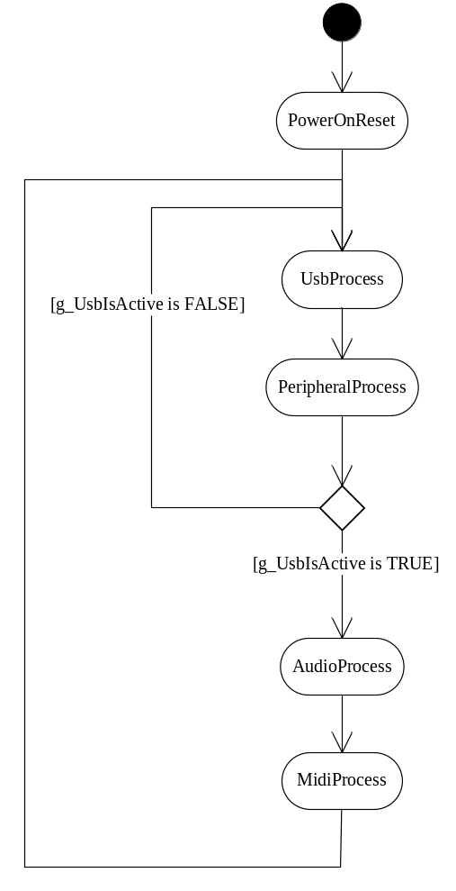

In “config.h”, there are macros for configuring the firmware. They are listed below.

Macros | Description
_MIDI_ | If “_MIDI_” is defined, firmware supports MIDI function. Otherwise, firmware doesn’t support MIDI.
_FULL_SPEED_ONLY_ | If “_FULL_SPEED_ONLY_” is defined, the device always operates in full-speed. Otherwise, firmware supports both full-speed and high-speed.
_AUDIO_CLASS_20_ONLY_ | If “_AUDIO_CLASS_20_ONLY_” is defined, the device always an audio class 2.0 device. Otherwise, firmware supports both audio class 1.0 and audio class 2.0 switched by pin XGPI4.
_I2C_SLAVE_SUPPORT_ | Enable the I2C slave interface of CM66xx.
_FEEDBACK_ | If “_FEEDBACK_” is defined, playback streams are run as asynchronous mode which has feedback endpoint. Otherwise, playback streams are run as synchronous mode.
_MCU_FEEDBACK_ | This macro can be defined only when “_FEEDBACK_” is defined. If “_MCU_FEEDBACK_” is not defined, the data returned via feedback endpoint is calculated by hardware automatically. If “_MCU_FEEDBACK_” is turned on, The feedback data is calculated by firmware.
_EXT_OSC_22_24_ | If “_EXT_OSC_22_24_” is defined, the clock source of I2S is external crystals 24.576 and 22.5792 MHz.
_EXT_OSC_45_49_ | If “_EXT_OSC_22_24_” is defined, the clock source of I2S is external crystals 49.152 and 45.1584 MHz. If neither “_EXT_OSC_22_24_” nor “_EXT_OSC_45_49_” is defined, the clock source of I2S is internal PLL which may have more jitter.
_EXT_CLK_SI5351_ | If “_EXT_CLK_SI5351_” is defined, the I2S clocks of front channel are provided by Si5351. This feature is only supported by CM6631A demo board.
VENDOR_ID | Define vendor ID of the USB device.
PRODUCT_ID | Define product ID of the USB device.
VERSION_ID | Define version ID of the USB device.

